1.Write a R program to create three vectors numeric data, character data and logical

data. Display the content of the vectors and their type.

Output:

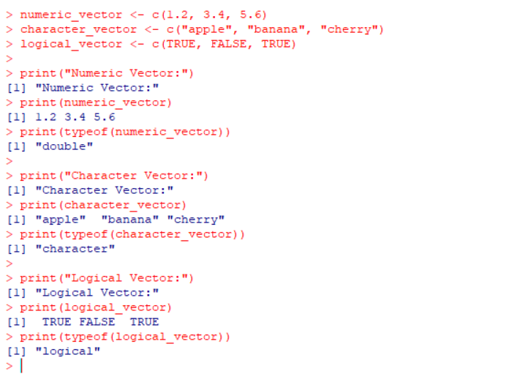

2. Write a R program to create a 5 x 4 matrix , 3 x 3 matrix with labels and fill the matrix

by rows and 2 × 2 matrix with labels and fill the matrix by columns.

Output:

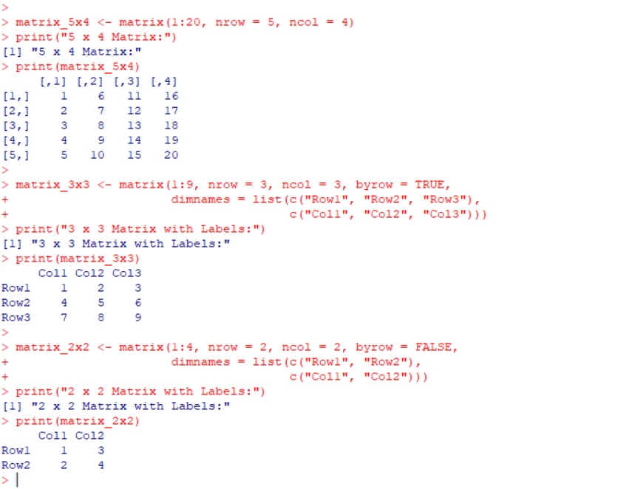

3.Write a R program to create an array, passing in a vector of values and a vector of

dimensions. Also provide names for each dimension.

Output:

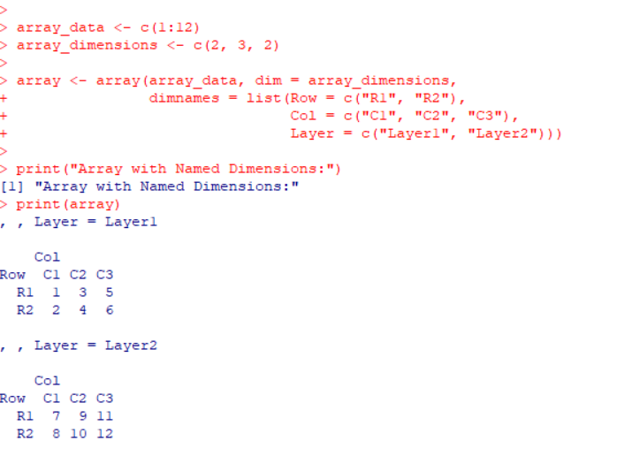

4. Write a R program to create an array with three columns, three rows, and two "tables",

taking two vectors as input to the array. Print the array.

Output:

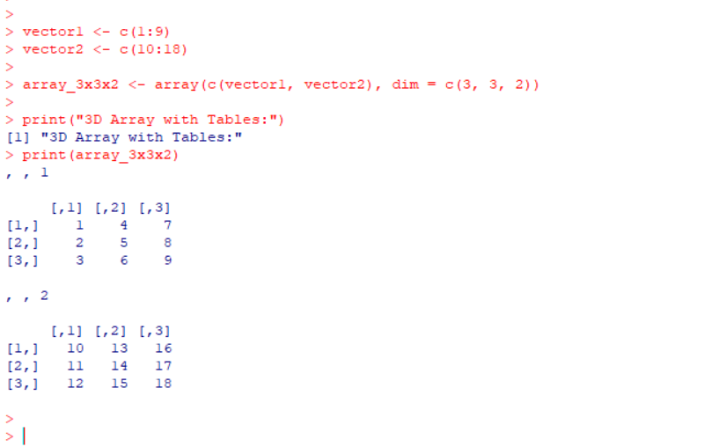

5.Write a R program to create a list of elements using vectors, matrices and a functions.

Print the content of the list.

Output:

